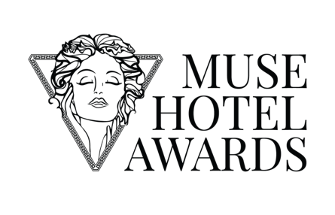
Contact:
(Contact Name) (Date)
(Hotel / Agency Name)
(Email)
(Phone)

FOR IMMEDIATE RELEASE
(Winner / Hotel / Agency Name) Secures (Platinum / Gold / Silver) Recognition at the 2026 MUSE Hotel Awards

(City, State - Date) – The 2026 MUSE Hotel Awards has officially revealed (Winner / Hotel / Agency Name) in the (Winning Category) as part of this year’s global winners for Season 1, recognizing outstanding achievements across two distinct areas of excellence: Hotel Performance & Guest Experience, and Hospitality Design.

With submissions received from over 30 countries spanning United States, United Kingdom, China, Turkey, Bulgaria, Canada, and beyond, the 2026 award reflects the continued evolution of hospitality as both a service-driven industry and a design-led discipline. As a global competition, the award evaluates entries without geographic limitation, ensuring that every hotel, resort, boutique property, and design studio competes on equal global footing.

Located in (City / Country), (Winner / Hotel / Agency Name) distinguished itself through (concise differentiator — e.g., operational innovation, immersive interior design, sustainable integration, elevated guest programming, architectural precision). The entry reflects a commitment to measurable standards in both execution and guest experience.

“(Insert winner quote. This should reflect strategic pride, team recognition, and forward-looking positioning — not just celebration.)”

(Insert Images of the Hotel / Design)

Additional details regarding the winning entry can be found at: (Insert Winning Entry URL)

“The MUSE Hotel Awards exists to recognize properties and design teams that operate at an international standard,” said Thomas Brandt, spokesperson of the International Awards Associate (IAA). “This year, (Winner / Hotel / Agency Name) demonstrates that excellence in hospitality is not defined by location, but by execution. The level of precision, service innovation, and design refinement we’ve seen confirms that global hospitality continues to advance further.”

About (Winner / Hotel / Agency Name)
(Insert 120 to 180-word brief background of the hotel, firm, or team, including notable design elements, location, ownership, management group, or recent achievements.)

About MUSE Hotel Awards
The MUSE Hotel Awards is an international competition dedicated to recognizing excellence in Hotel Excellence and Hospitality Design. Through a transparent blind judging process and globally diverse jury panel, the program honors properties and design professionals that establish elevated standards across the hospitality industry.

Website: musehotelawards.com
X: musehotelawards
Facebook: musehotelawards
Instagram: musehotelawards
Media Partner: Muse.World

- ### -

